|  |  |
| --- | --- |
| logo ngan.png | MINISTRY OF EDUCATION AND TRAINING |

|  |
| --- |
| **FPT UNIVERSITY** |
| Capstone Project Document |
| Build a Web Application  for manages all activities of  delivery service system by coach |
|  |
| |  |  | | --- | --- | | **Group 18** | | | **Group Members** | Đào Bảo Long – Team Leader – SE60690  Lê Phúc Lữ – Team Member – 60563  Nguyễn Thanh Tùng – Team Member – SE60609  Nguyễn Tấn Đức – Team Member – SE60660 | | **Supervisor** | Nguyễn Trọng Tài | | **Ext Supervisor** | N/A | | **Capstone Project Code** | i-Deliver | |
| Hồ Chí Minh City, April 2014 - |

*Acknowledgement*

After more than three months of intensive researching, working, and having fun, we have finally reached the fundamental objectives of the project *Multi-Hotel Booking*. Apart from our own efforts, the completion of this project depends largely on the encouragement and guidelines of many others. We would like to dedicate this page to expressing our gratitude to the people who have been instrumental in our project.

Firstly and most importantly, we would like to show our greatest respect to Mr. Lâm Hữu Khánh Phương, our supervisor, whose tremendous support and surprising yet innovative ideas contributed a great deal to the completion of our project. Without his encouragement and guidance, this project would probably not have materialized. More than that, we really appreciate the fact that he put us under no pressure whatsoever and always let us having fun while we were working on this project.

Secondly, we would like to thank our fellow men in Group 11, who were also working on a similar project. We will never forget the moments when we were so drawn into arguments that led to nowhere that we even thought we would end up failing to finish our projects. It was an extraordinarily interesting experience having worked together.

Finally, we would like to express our deepest gratitude to our parents and our lecturers for always being there for us. We appreciate that they did a lot to gear us up for all the things we might encounter in our lives. We would not be who we are today if it weren’t for them.

Group 18  
*Nguyễn Phú An,  
Bùi Minh Đức,  
Nguyễn Hiếu Triệu Vỹ*

*This page is intentionally left blank*

# Table of contents

Table of contents 4

Table of figures 6

Terminology 7

6. Software User’s Manual 8

6.1. Installation Guide 8

6.1.1. Prerequisites 8

6.1.2. Installation procedures 8

6.2. User’s Guide 15

6.2.1. Guides for Customer 15

6.2.1.1. Log in to the system 15

6.2.1.2. Log out of the system 15

6.2.1.3. Register an account with Customer role 16

6.2.1.4. Sent a delivery request 16

6.2.1.5. View station details, rate, and comment 19

6.2.1.6. Online payment 20

6.2.1.7. Tracking package(s) 23

6.2.2. Guides for Staffs and System Admins 23

6.2.2.1. Approve pending requests 23

6.2.2.2. Create a trip 24

6.2.2.3. Assign package(s) 26

6.2.2.4. Confirm package(s) departed from start-station 26

6.2.2.5. Confirm package(s) arrived in end-station 27

6.2.2.6. Confirm package(s) delivered 28

6.2.2.7. Prepare package(s) for return 28

6.2.2.8. Extend due-date for online payment 29

6.2.2.9. Statistics 30

6.2.2.10. Add a price 32

6.2.2.11. Monitor prices 33

Appendix 33

Reference 33

# Table of figures

**No table of figures entries found.**

**No table of figures entries found.**

# Terminology

|  |  |  |
| --- | --- | --- |
| No. | Terminology | Explanation |
| 1. | Customer | A person who needs to book rooms in hotels at their destination |
| 2. | Staff | A person in charge of managing their hotels |
| 3. | System Administrator | A system that provides hotel data including hotel information, room availability, and price changes |
| 4. | Delivery Request | A request sent by a customer to the staff to ask for a delivery request with the I-DELIVER system |

# Software User’s Manual



## Installation Guide

### Prerequisites

Before we install the application and throw it into operation, the preconditions about the environment and tools specified below must be satisfied.

Firstly, system requirements for the I-DELIVER application to run on top of are specified below:

* Personal computers for the minimum configuration: 2 Gb of RAM, 50Gb of hard disk, Core 2 Duo 2.0 Ghz;
* Microsoft Windows 7 or higher.
* At least 100MB for the application resources, and another 100MB for data storage.

Secondly, these tools must be installed in advance and run without errors:

* IIS Express 7.0 or higher
* SQL Server 2008 or higher,
* .NET Framework 4.5,
* WebDeploy 3.5

### Installation procedures

The following installation guides are composed using IIS Express 8.0, SQL Server 2012, .NET Framework 4.5 and WebDeploy 3.5. If you are using another version of these tools, the installation procedures might be a little bit different.

**Step** 1. Prepare the deployment package

Extract the deployment package to a folder on the server, for example, D:\Capstone Project\I-DELIVER.

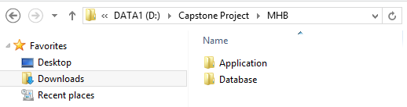

**Step 2. Create the database**

Open the file “DB1.0.sql” in the folder “Database” of the deployment package by Microsoft SQL Server Management Studio (MSSQL).

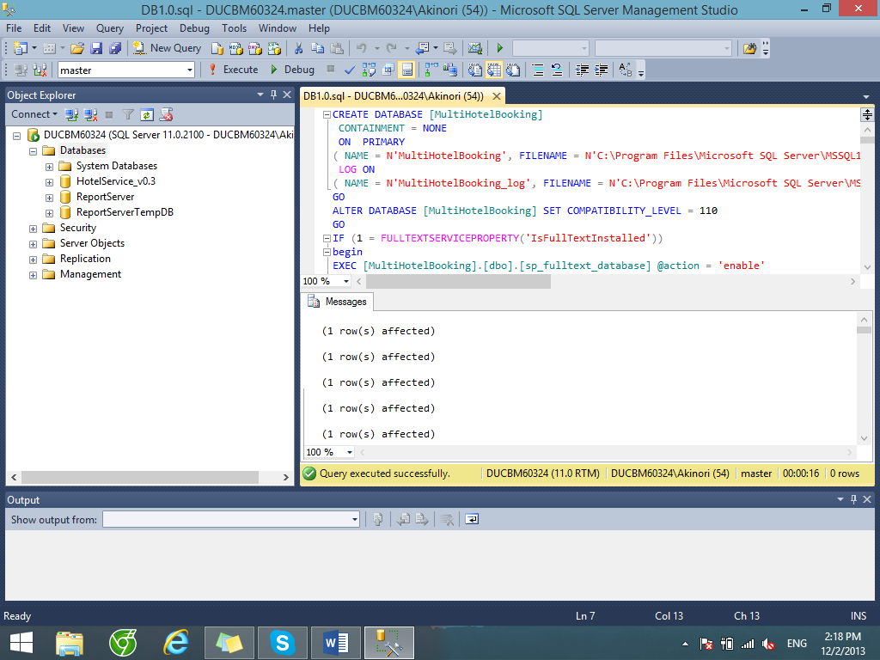

Change the paths of the SQL server where the databases are stored. Usually this file path has the form “C:\Program Files\Microsoft SQL Server\***<SQLServerInstanceName>***\MSSQL\DATA”.

Next, press F5 or the Execute button to run the database script. If the database is created successfully, continue to the next step.

**Step 3. Install the application**

Open the IIS Manager by typing its name into the search box in the start menu in Windows 7 or the charm bar in Windows 8.

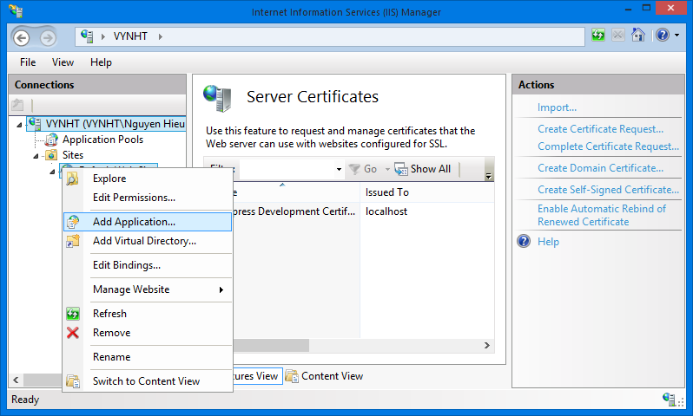

Expand the Sites folder and then right click on Default Web Site. Select “Add Application…” to open Add Application window. In the “Add application” window, fill the field “Alias” with the name of the website.

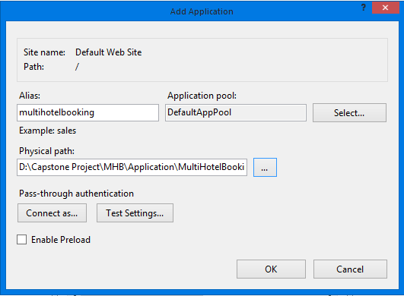

Click the “…” button to browse to the folder that contains the deployment package. Select the “Website” folder in the “MultiHotelBooking” folder, in the “Application” folder and click OK.

Verify that the MultiHotelBooking Website has been added to “Default Web Site” of IIS Express by right-clicking the website’s name, choosing “Manage Application” and then “Browse”.

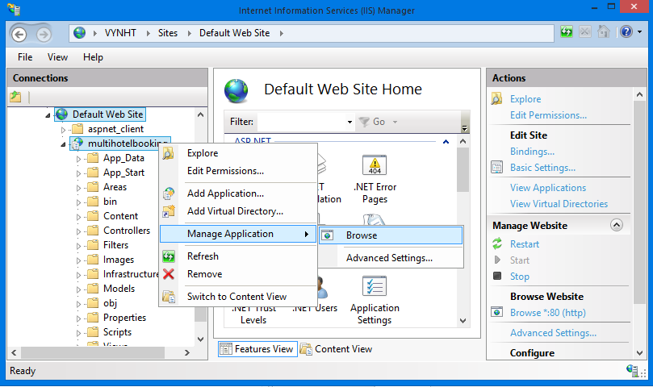

Note that at this step, you will see an error connecting to the database, because you didn’t change the database connection configuration. We will solve it shorly.

**[Optional] Step 4**. **Create a new Self Signed Certificate**

This step is to enable SSL browsing to your application when it is installed on Facebook.

Certificates are managed in IIS by clicking the root machine node in the left-hand tree-view explorer, and then selecting the "Server Certificates" icon in the feature pane on the right:

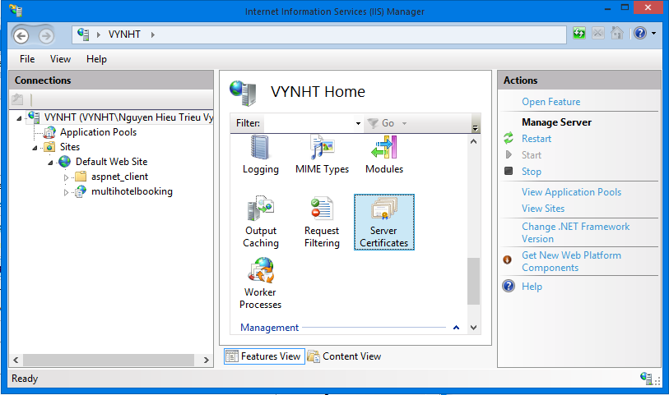

This will then list all certificates registered on the machine, and allow you to optionally import and/or create new ones.

You could optionally go to a certificate authority like Verisign and purchase a certificate to import using this admin UI. Alternatively, you can create a “self-signed certificate” which is a test certificate that I can use during the development and testing of my site. To do this, click the “Create Self-Signed Certificate” link on the right-hand side of the admin tool:

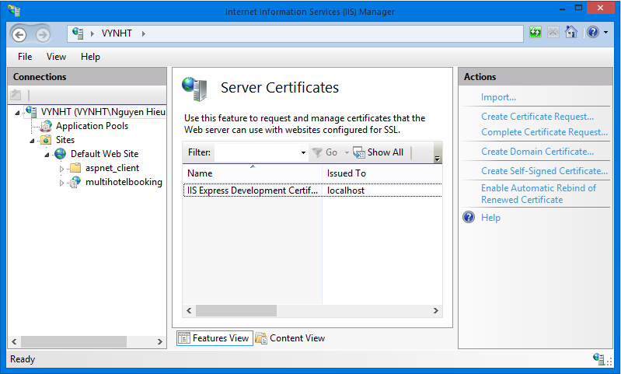

Enter a name to use for the certificate (for example: "test") and hit ok. IIS will then automatically create a new self-signed crypto certificate for you and register it on the machine:

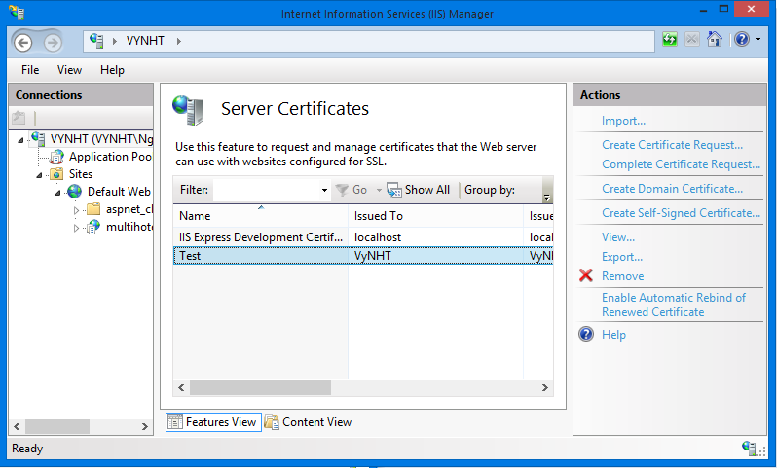

To SSL enable the web-site we created earlier, select the web-site node in the left-hand tree-view, and the click the “Bindings” link in its “actions” pane on the right-hand side of the screen:

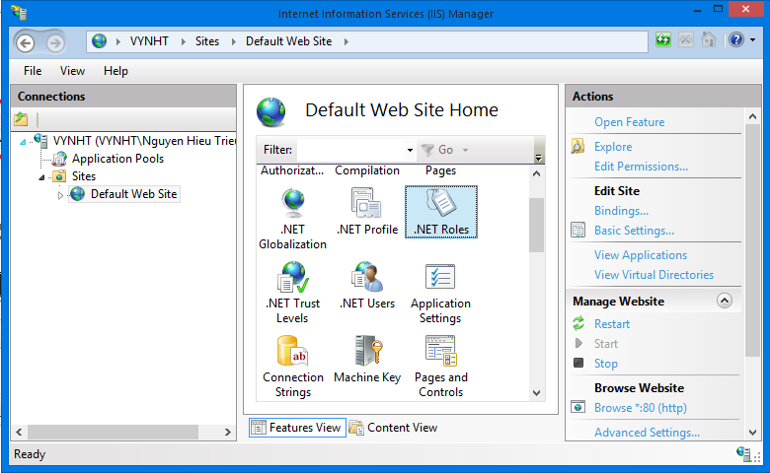

This will then bring up a dialog that lists all of the binding rules that direct traffic to this site (meaning the host-header/IP address/port combinations for the site):

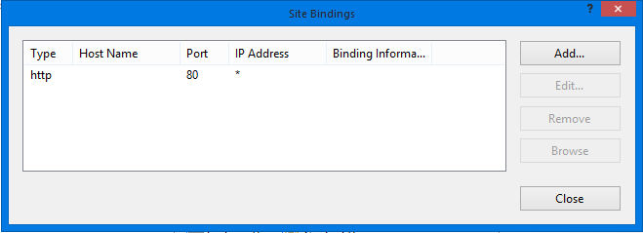

To enable SSL for the site, we'll want to click the “Add” button. This will bring up an “add binding” dialog that we can use to add HTTPS protocol support. We can select the self-signed certificate we created earlier from the SSL certificate dropdownlist in the dialog, and in doing so indicate that we want to use that certificate when encrypting content over SSL:

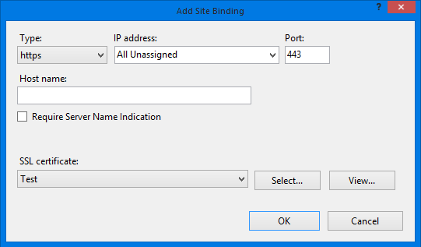

Click “OK”, and we now have SSL enabled for our site.

**Step 5. Configure database connection string**

In the “Application\MultiHotelBooking\Website” folder of the deployment package, find and open the file Web.config using Notepad or any other text editor.

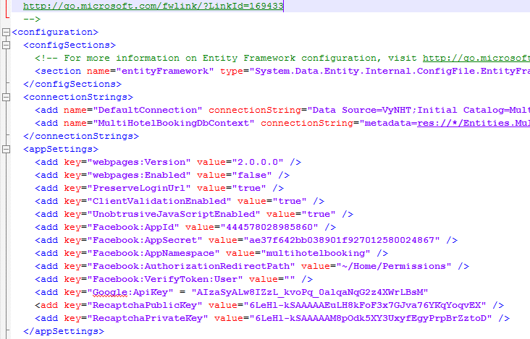

In the connectionStrings tag, change the Data Source of the connection strings to the SQLServer instance where you installed the database. Also, update the password to access the SQLServer instance in the connection strings.

**Step 6. Configure Facebook app**

Go to your Facebook app at <https://developers.facebook.com/apps/> (if you don’t have one, here is how to create one <https://developers.facebook.com/docs/opengraph/getting-started/>).

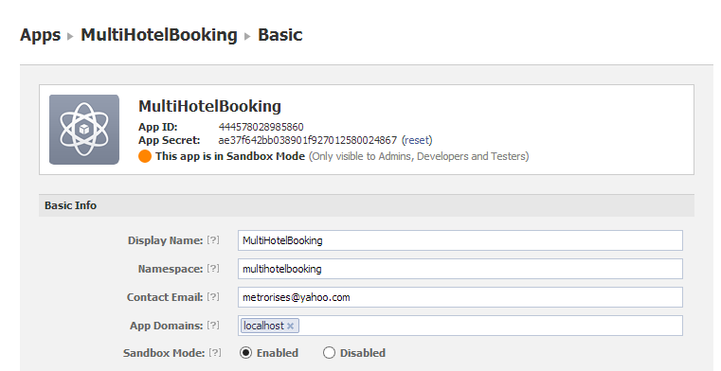

Update the App Id, App Secret, and Namespace for the app in the web.config file.

**Step 6**. **Configure the Facebook app as follows.**

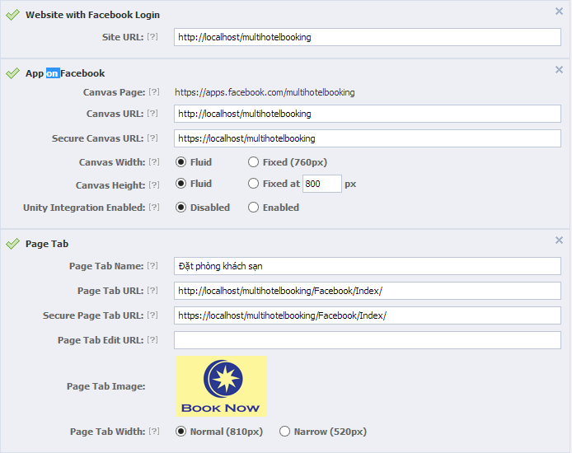

In the configuration below, “multihotelbooking” is the name of the website (Alias) you’ve just installed on IIS.

|  |  |
| --- | --- |
| Field Name | Value |
| *Site Url* | <http://localhost/multihotelbooking> |
| *Canvas Url* | <http://localhost/multihotelbooking> |
| *Secure Canvas Url* | <https://localhost/multihotelbooking> |
| *Page Tab Name* | The name of the app displayed on the fan pages |
| *Page Tab Url* | <http://localhost/multihotelbooking/Facebook/Index> |
| *Secure Page Ta Url* | <https://localhost/multihotelbooking/Facebook/Index> |
| *Page Tab Image* | An image for the app |

You can also update your own Google API Key and Recaptcha public and private keys if you would like to. Now go to [**http://localhost/multihotelbooking**](http://localhost/multihotelbooking) and [**https://localhost/multihotelbooking**](https://localhost/multihotelbooking) and enjoy the website**.**

## User’s Guide



### Guides for Customer



#### Log in to the system

This function allows a user with a registered account to log in to the i-Deliver system.



4

4

3

2

1

Screen . Login screen

|  |  |
| --- | --- |
| Step | Instruction |
| 1. | Click the “Đăng nhập” button on the menu bar of the “Trang chủ” page. |
| 2. | Fill the registered account in the “Tên đăng nhập” field |
| 3. | Fill the password in the “Mật khẩu” field |
| 4. | Click the “Đăng nhập” button to log in to the system. You will be redirected to the page you are viewing |

#### Log out of the system

This function allows the user to log out of the system after he or she finishes browsing the website.



1

Screen . Logout screen

|  |  |
| --- | --- |
| Step | Instruction |
| 1. | Click the “Đăng xuất” link on top right of page you are viewing. You will be redirected to the page you are viewing if this page allows guests to access or the “Trang chủ” page otherwise. |

#### Register an account with Customer role

This function allows the user to register a new account with Customer role in the i-Deliver system.

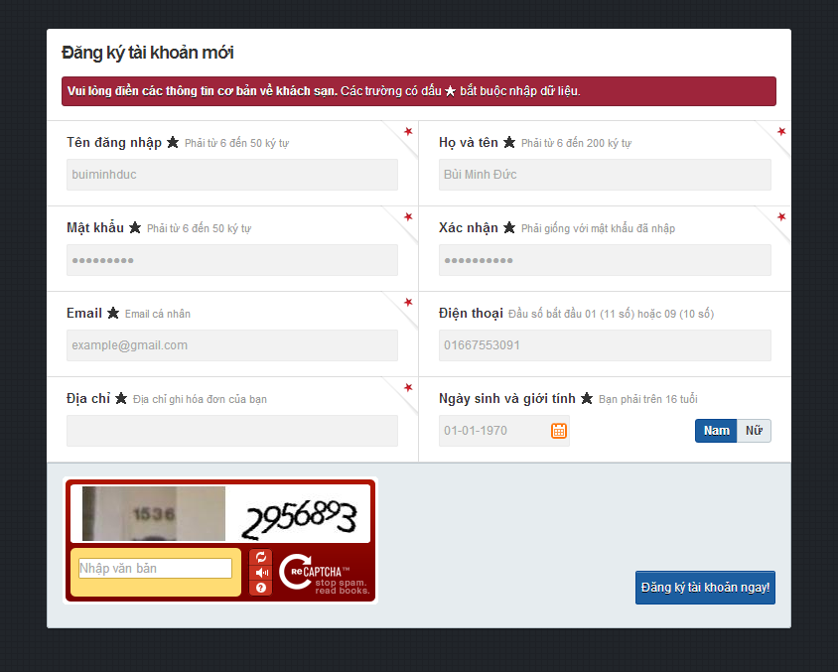

3

4

5

Screen . Register screen

|  |  |
| --- | --- |
| Step | Instruction |
| 1. | Click the “Đăng nhập” button on the menu bar of the “Trang chủ” page. |
| 2. | Click “Đăng ký ngay” on the “Đăng nhập” popup (Screen 2). The system will redirect you to “Đăng ký” page. |
| 3. | Fill in the fields “Tên đăng nhập”, “Họ và tên”, “Mật khẩu”, “Xác nhận”, “Email” “Điện thoại”, “Địa chỉ”, “Ngày sinh”, and “Giới tính” with your username, full name, password, password, email address, phone number, address line, date of birth, and gender.  Your input will be validated as you type. Please make sure that all the values that you provide are validated. |
| 4. | Fill in the “Nhập văn bản” field with the numbers or characters in the captcha image. |
| 5. | Click the button “Đăng ký tài khoản ngay” to proceed to register your account with Traveler role.  If registered successfully, you will be redirected to the “Đăng nhập” page to login with the newly created account. |

#### Sent a delivery request

This function allows the user to sent a delivery request to the i-Deliver system.

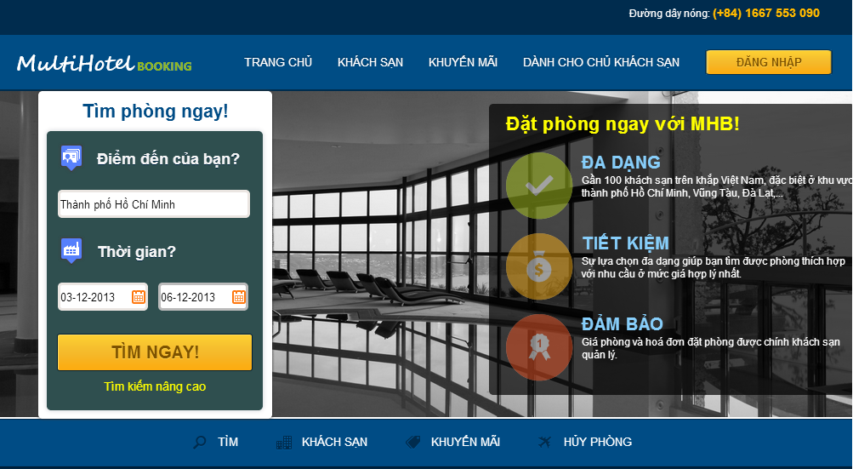

2

3

1

Screen . Home page screen

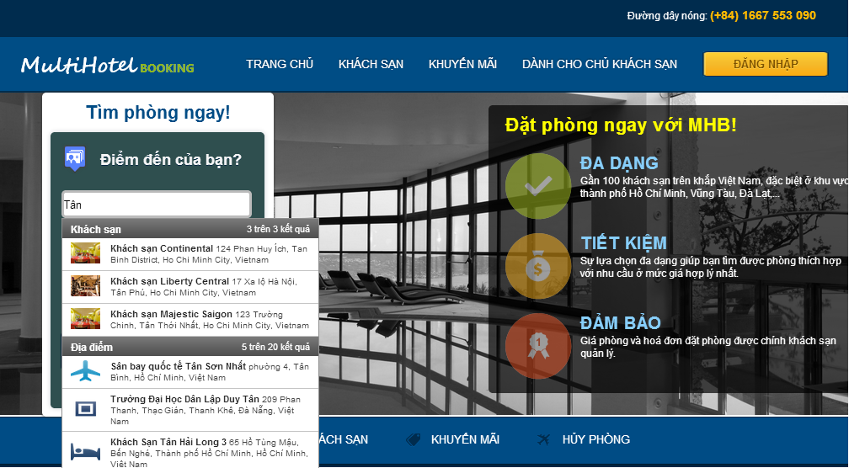

Screen . Places suggestion screen

|  |  |
| --- | --- |
| Step | Instruction |
| 1. | Fill in the textbox “Điểm đến của bạn?” with a place, city, or hotel name.  A list of suggestions will appear as you type. Select one item of the suggestions to specify the place of your destination. |
| 2. | Pick a date for checking in and a date for checking out. Your input will be validated as you picked a date. |
| 3. | Click the button “Tìm ngay”. You will be redirected to the hotel search page. |

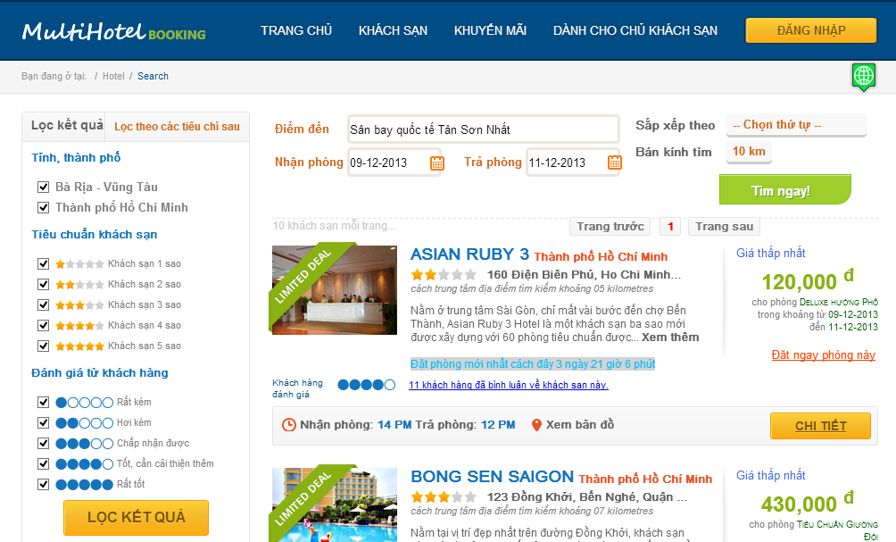

7

4

6

5

Screen . Search hotel screen

|  |  |
| --- | --- |
| Step | Instruction |
| 4. | You can change your searching criteria to limit or expand the results. The website will behave as when you search in the home page. |
| 5. | Specify some filters on the results by   * Checking or unchecking cities in “Tỉnh, thành phố” section; * Checking or unchecking hotel’s stars in “Tiêu chuẩn khách sạn” section; * Checking or unchecking average rating point of customers in “Đánh giá từ khách hàng” section. |
| 6. | Click the “Lọc kết quả” button. The system will filter the results without refreshing the page. |
| 7. | You can view all the searched and filtered hotels on the Google map by clicking the button marked 7 in the search hotel screen. The hotels are numbered as in the result list. |

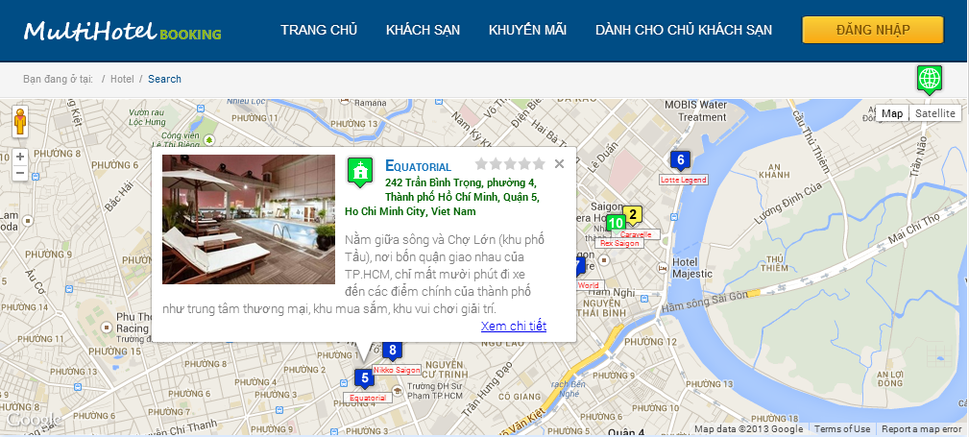

Screen . Hotels on google map screen

#### View station details, rate, and comment

This function allows the customer to view details of a station information, review, and rate the station.



1

Screen . Search results screen

2

3

4

|  |  |
| --- | --- |
| Step | Instruction |
| 1. | Click the “Chi tiết” button in the result list of the hotel search page. You will be redirected to the hotel details page of the selected hotel. |

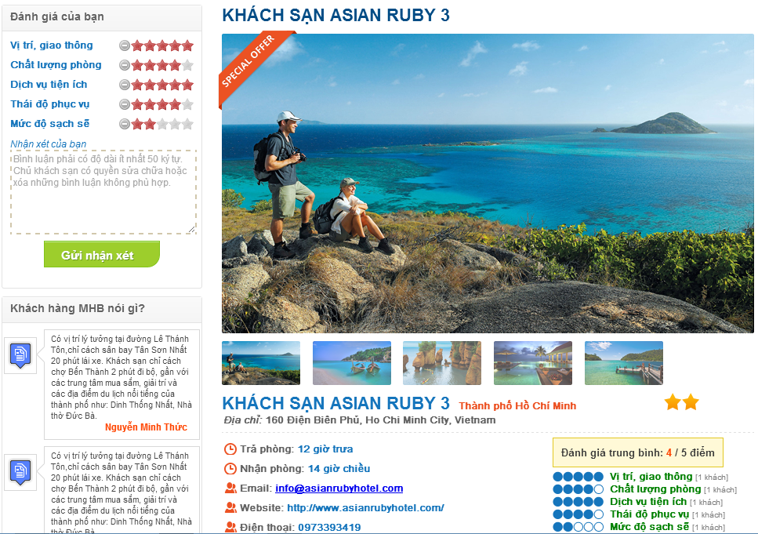

Screen 9. Hotel details screen

|  |  |
| --- | --- |
| Step | Instruction |
| 2. | (Optional) Rate the hotel by different critiaria like location and traffic, room quality, hotel services, staff attitude, cleanliness by checking the number of stars for each criterion in “Đánh giá của bạn” |
| 3. | (Optional) Fill your review about the hotel in the box “Nhận xét của bạn”. The content of the review can be your opinion on the hotel services, your personal experience, and what needs to be improved. |
| 4. | (Optional) Press the button “Gửi nhận xét” in order to submit a review for the hotel. |

#### Online payment

This function allows the customer make a payment online via PayPal.

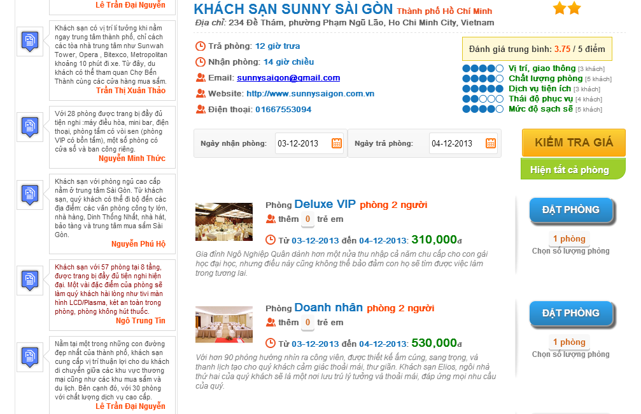

**1**

**2**

**4**

**3**

**5**

Screen . Room details screen

|  |  |
| --- | --- |
| Step | Instruction |
| 1. | Pick a date for checking in to fill the textbox “Ngày nhận phòng” and a date for checking out to fill the textbox “Ngày trả phòng”. Your dates will be validated before you continue. |
| 2. | Click the “Kiểm tra giá” button to check for room availability and prices. If there are available rooms in the specified period, the system will list their information and prices in the list below. |
| 3. | (Optional) Choose number of rooms in the rectangular under “Đặt phòng” button. The default value for number of rooms is 1. |
| 4. | (Optional) Choose number of extra children or adults, if allowed by the hotel. |
| 5. | Click the “Đặt phòng” button. The system will drive you to Booking Details Page. |

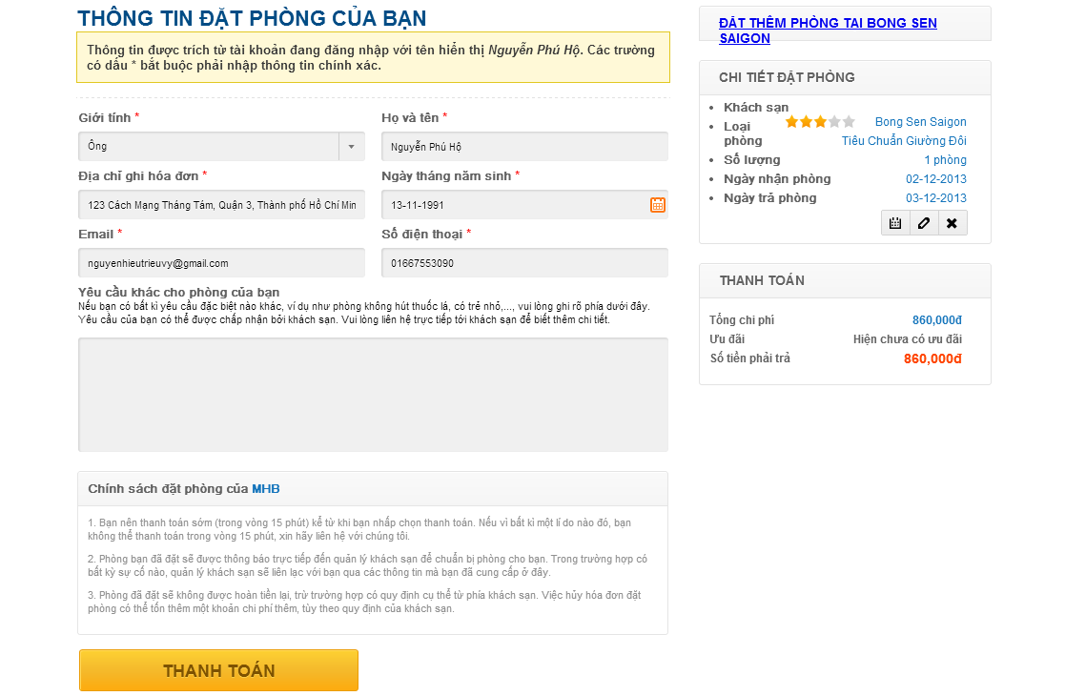

**8**

**6**

**7**

Screen . Booking details screen

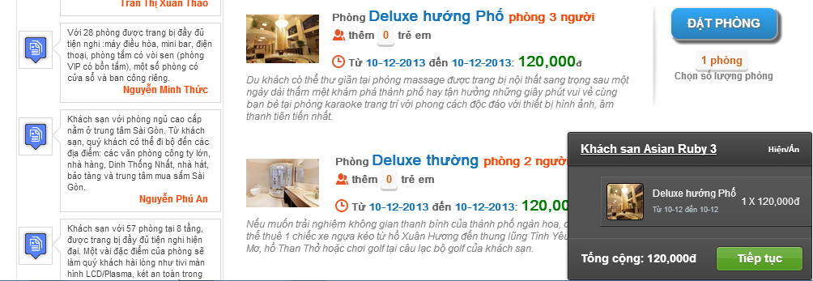

Screen . Book more rooms screen

|  |  |
| --- | --- |
| Step | Instruction |
| 6. | (Optional) Click on the link “Đặt thêm phòng tại khách sạn X”, where X is the name of the selected hotel to book more rooms of this hotel. Repeat the steps from 1 to 5 to add more rooms to the booking list. |
| 7. | Fill in the customer information form. If you are already logged in the website, the details of your account will be automatically filled in the form.  Provide us your real gender, full name, address, date of birth, email, phone number and specify any request you want to send to the hotel owner. Your input will be validated as you type and will be used for the hotel owner to verify your booking when you check in the hotel, so please make sure you enter accurate information. |
| 8. | Click the button “Thanh toán”. You will be redirected to “Ngân Lượng” payment service. |

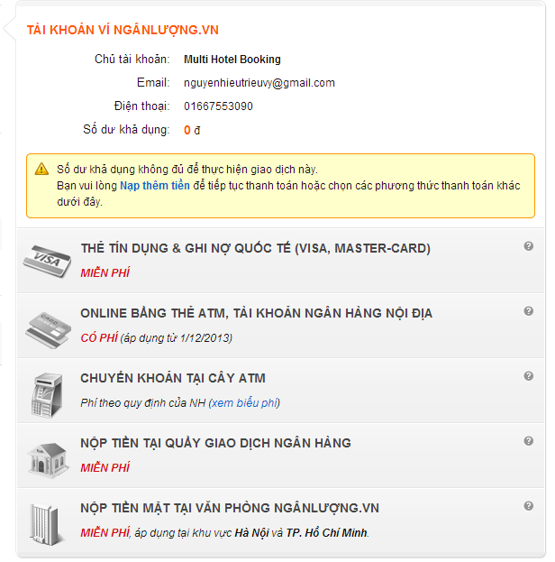

**9**

Screen . Ngân Lượng payment screen

|  |  |
| --- | --- |
| Step | Instruction |
| 9. | Pay for the rooms using your “Ngân Lượng” account. If the payment was made successfully, you will be redirected to the booking success page. |
| 10. | An email of the booking details will be sent to your email address. An SMS message containing your booking code will be sent to your phone number. Use this booking code and your personal information to verify with the hotel when you check in. |
| 11. | The booking success page shows your booking details and your booking code. Record this code to use to verify with the hotel when you check in. |

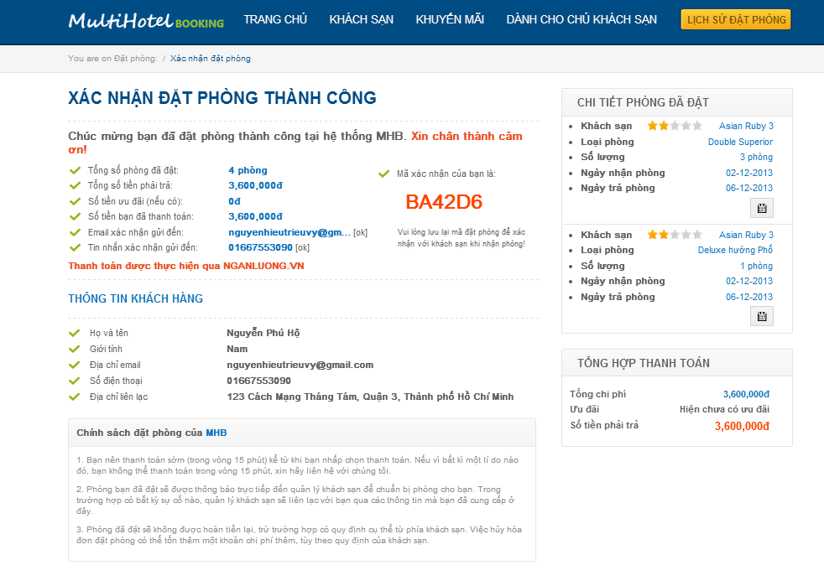

**11**

Screen . Booking success screen

#### Tracking package(s)

### Guides for Staffs and System Admins



#### Approve pending requests

This function allows the staff to view all pending requests, input invoice for each request by click “Nhập hóa đơn” button then approve it after confirm payment for request by click “Xác nhận thanh toán” button.

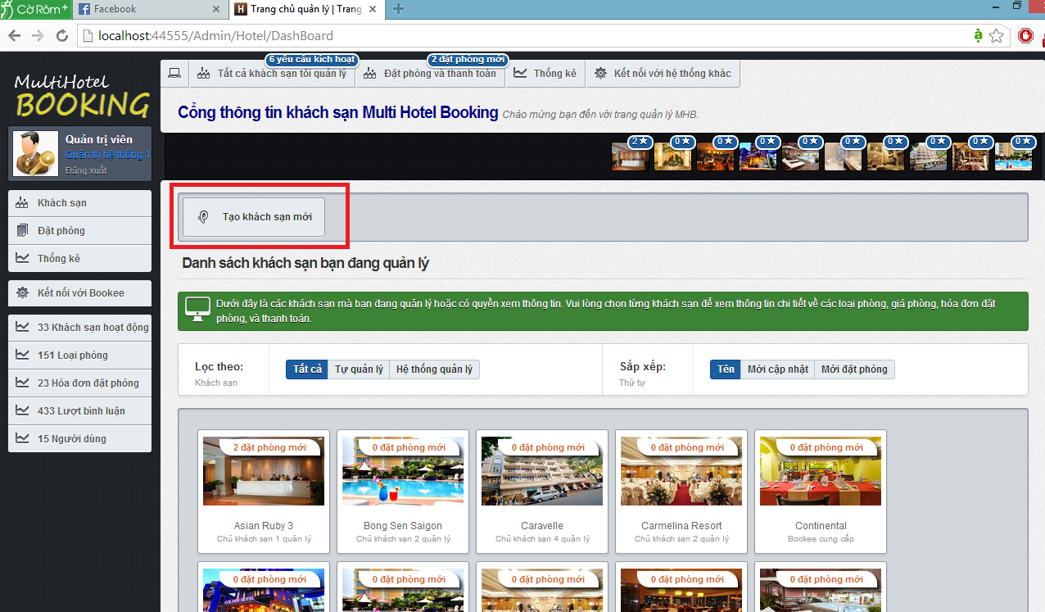

**7**

**6**

Screen 15. Admin dashboard screen

**5**

**4**

**3**

**2**

**1**

|  |  |
| --- | --- |
| Section | Description |
| 1. | The number of hotel opening request by hotel owner. This section is only available to System Admins. |
| 2. | The number of new bookings that need to be approved. |
| 3. | Ten hotels under your management that have the most new bookings. |
| 4. | Filters on local and external hotel. |
| 5. | Orders in which the hotels under your management should be displayed |
| 6. | All the hotels under your management |
| 7. | The menu bar that contains links to other pages. |

#### Create a trip

This function allows the staff to create a new trip for the system.

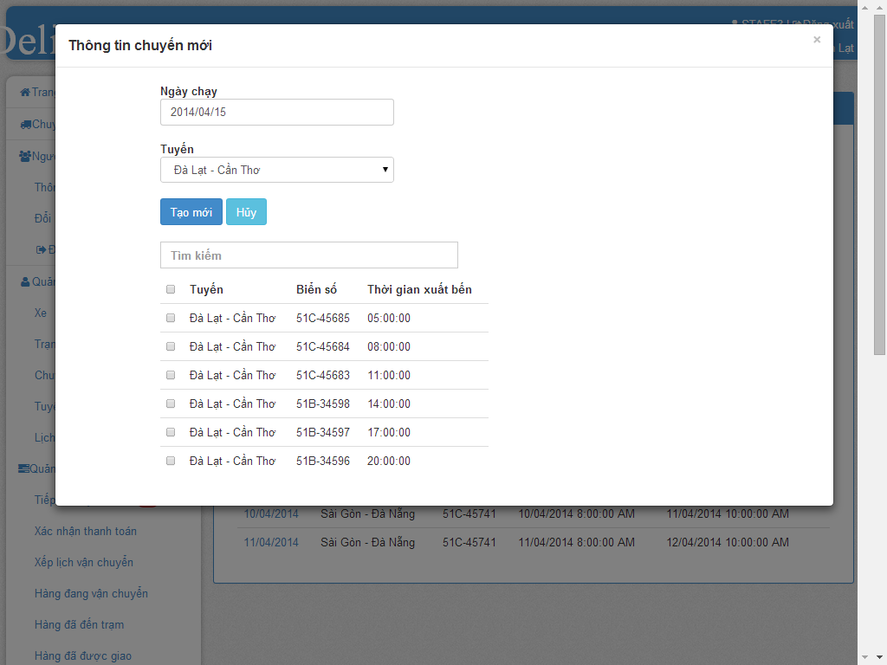

**3**

**2**

**1**

Screen . Create a hotel screen

|  |  |
| --- | --- |
| Step | Instruction |
| 1. | Select a date from datepicker |
| 2. | Select a route from select list |
| 3. | Check box to select specify schedule for selected route |
| 4. | Click “Tạo mới” to create new trip for selected route in selected date |

**6**

**5**

**4**

#### Assign package(s)

This function allows the user to delete a hotel under your management from the system. All the information related to this hotel (room types, prices, features, images…) will be deleted too.

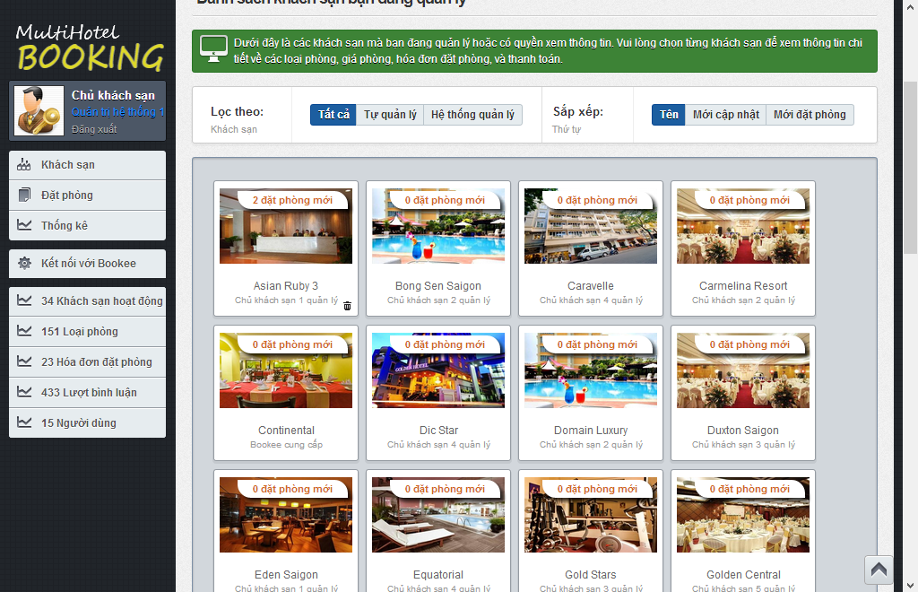

**1**

Screen . Delete a hotel screen

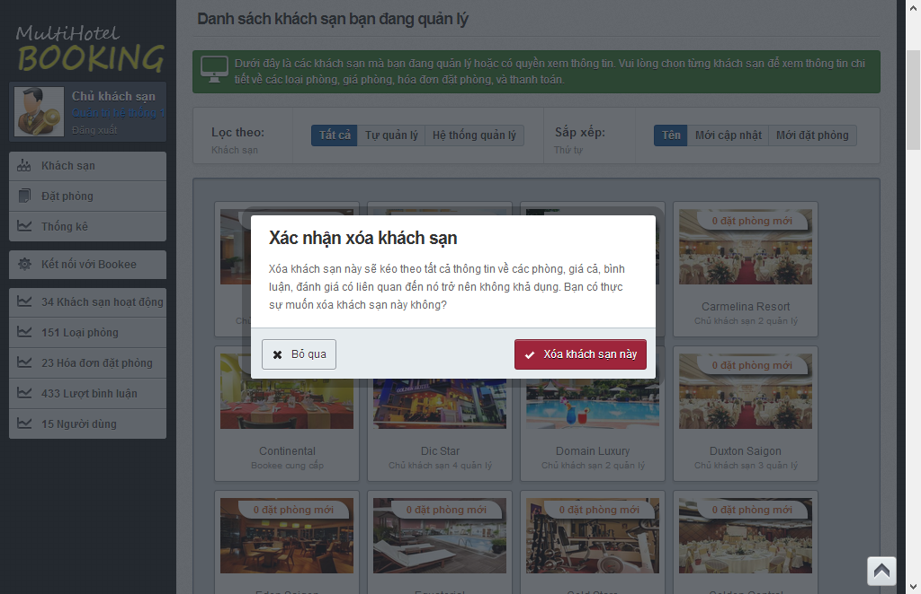

**2**

|  |  |
| --- | --- |
| Step | Instruction |
| 1. | Hover your mouse over a hotel and click  button. A pop up will be displayed to ask you to confirm if you really want to delete the hotel. |
| 2. | Click “Bỏ qua” button if you don’t to delete this hotel; or  Click “Xóa khách sạn này” button if you want to delete this hotel. |

#### Confirm package(s) departed from start-station

This function allows the user to add a new room type for an existing hotel.

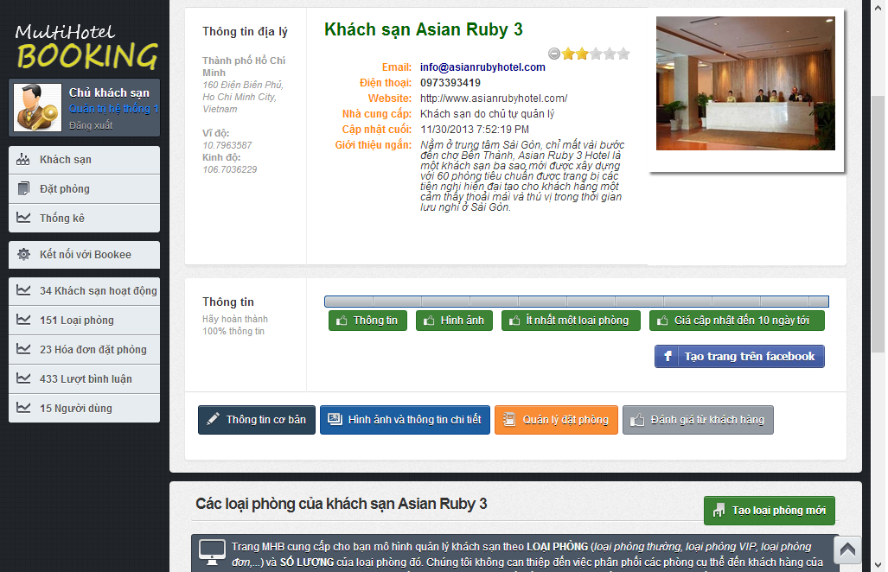

**1**

Screen . Hotel Details screen

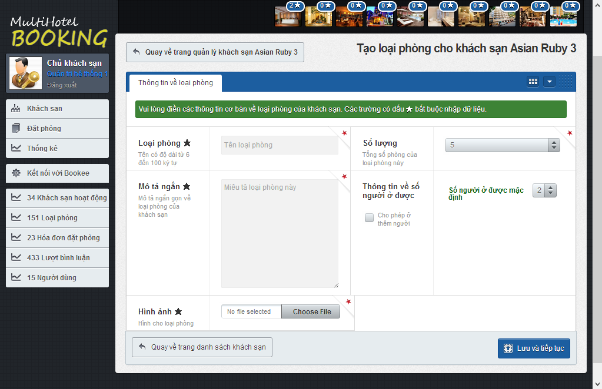

**3**

**2**

Screen . Add a room type screen

|  |  |
| --- | --- |
| Step | Instruction |
| 1. | Click the button “Tạo loại phòng mới” button in Hotel details page of the hotel you want to create a new room type. |
| 2. | Provide necessary information for the room type.   * Fill the name of the room type in the “Loại phòng” textbox; * Choose the number of rooms of this type in the “Số lượng” dropdownlist; * Fill a short description about this room type in the box “Mô tả ngắn” * Choose default number of persons who can stay in this room in the “Số người ở được mặc định” dropdown list and check/uncheck “Cho phép ở thêm người” to allow or not allow extra persons. * Choose room’s picture in “Hình ảnh” textbox by click “Choose file” button then choose a picture file and click Open. |
| 4. | Click the “Lưu và tiếp tục” button. The system will save the room type and redirect you back to the hotel management page of the room type newly added. |

#### Confirm package(s) arrived in end-station

This function allows the user to delete a room type of a hotel under your management from the system. All the information related to this room type will be deleted too.

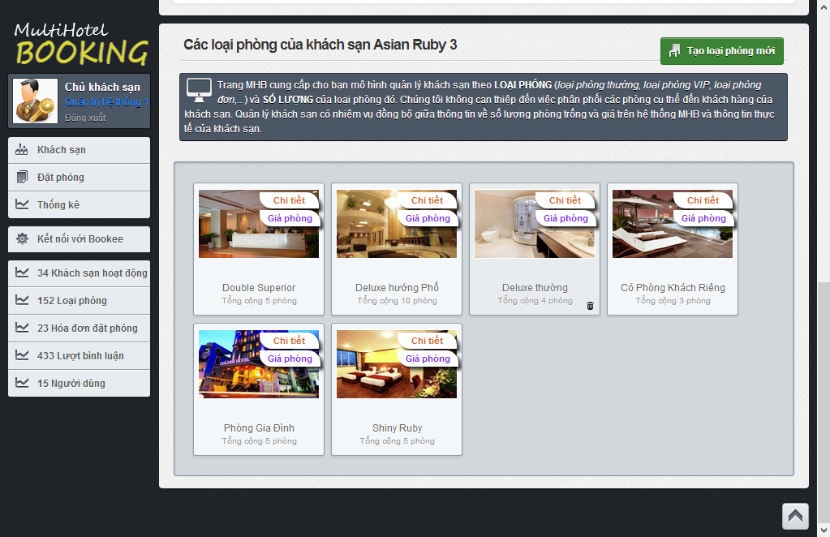

1

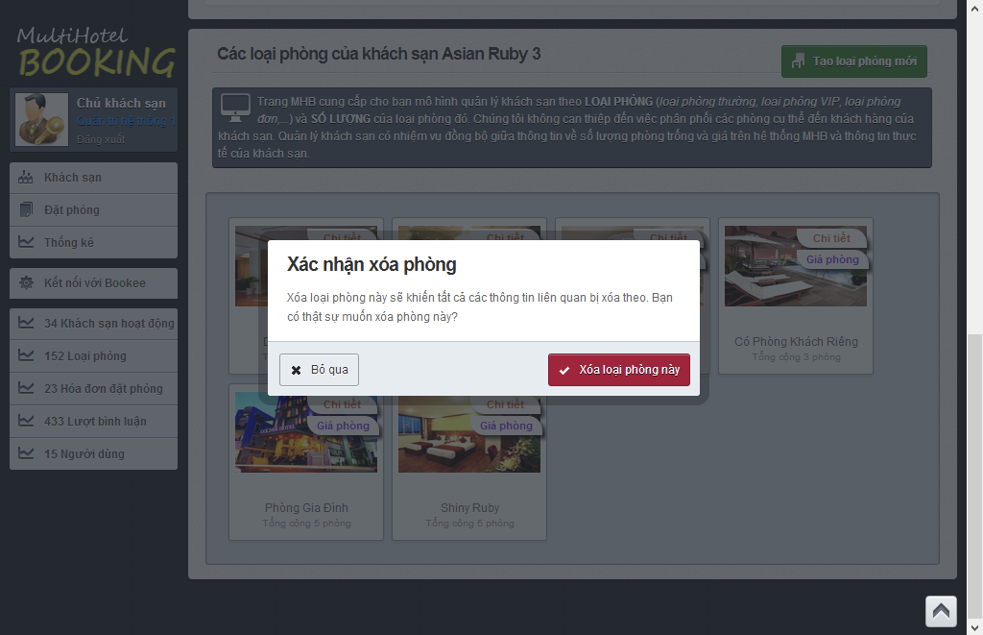

2

Screen . Delete a room type screen

|  |  |
| --- | --- |
| Step | Instruction |
| 1. | Hover your mouse over a room type and click  button. A pop up will be displayed to ask you to confirm if you really want to delete the room type. |
| 2. | Click “Bỏ qua” button if you don’t to delete this room type; or  Click “Xóa khách sạn này” button if you want to room type this hotel. |

#### Confirm package(s) delivered

This function allows a hotel owner to easily update the start date and end date of a price.

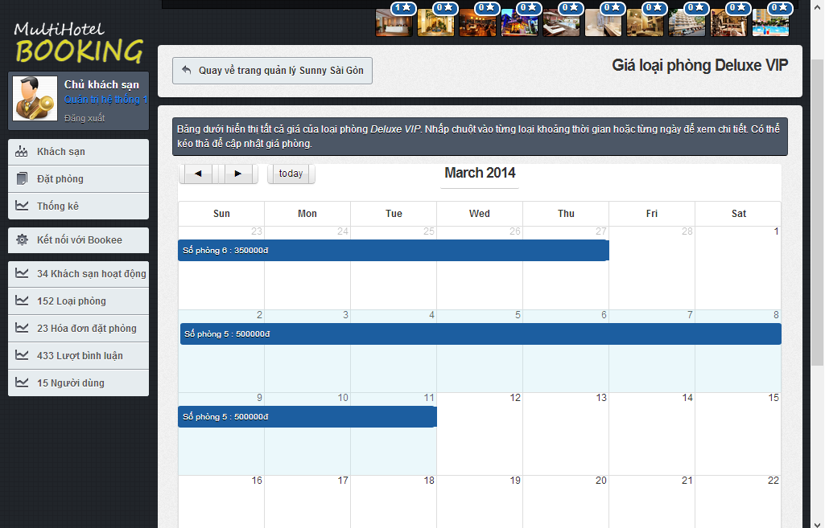

2

1

Screen . Resize a price screen

|  |  |
| --- | --- |
| Step | Instruction |
| 1. | **(**Optional) Click and hold the edge of a price bar you want to resize and drag it to your desired position in the price calendar. Release the mouse to update the price to the new position in calendar. |
| 2. | (Optional) Click and hold a price bar in the price calendar, then drag it to new position in the calendar. Release the mouse to drop the price to the new position in calendar. |

#### Prepare package(s) for return

This function allows the user to verify that he or she has approved of a booking made by a customer.

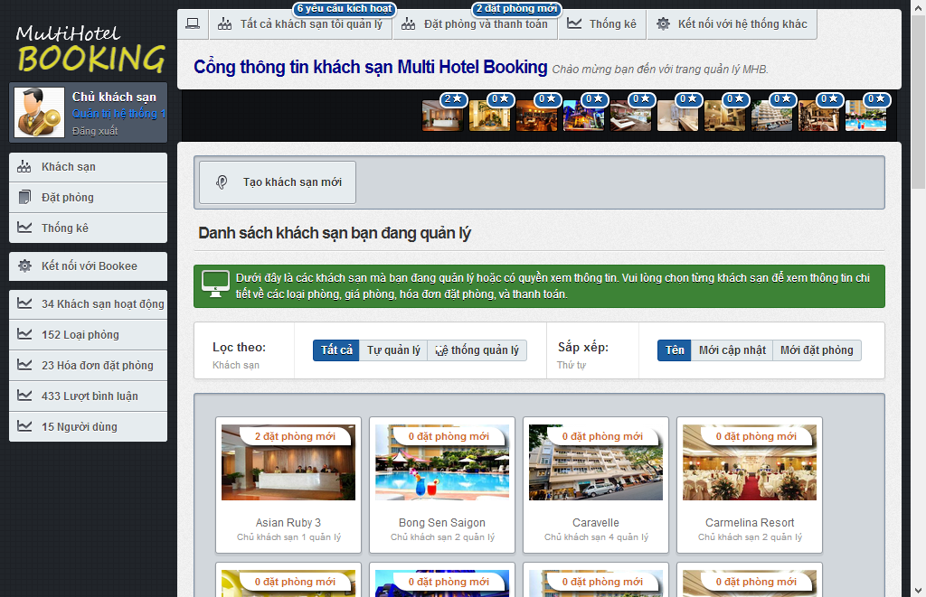

1

1

Screen . Dashboard screen

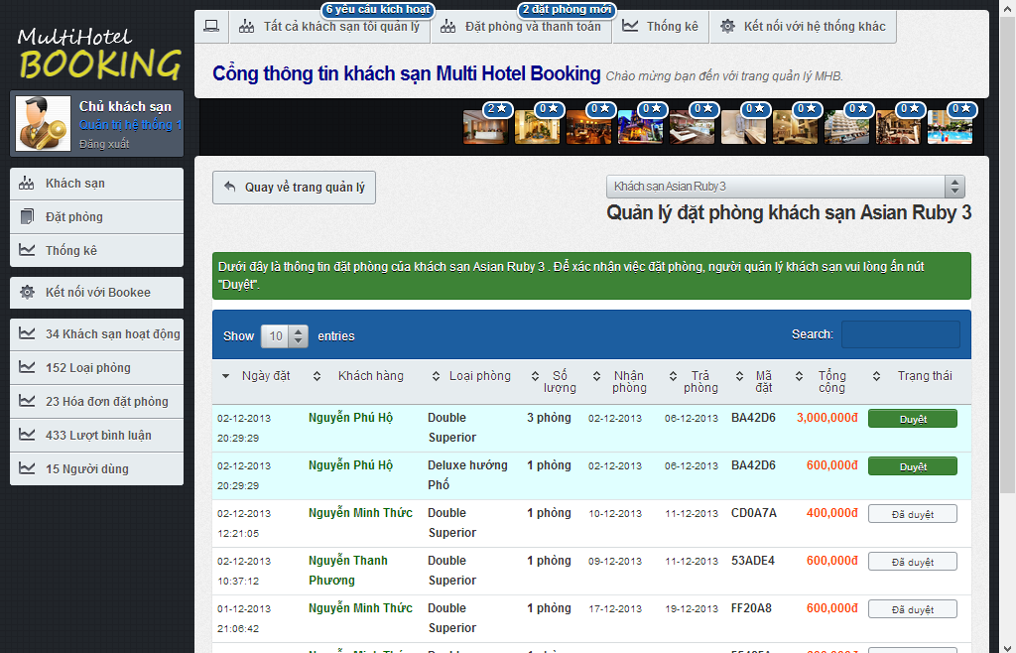

2

|  |  |
| --- | --- |
| Step | Instruction |
| 1. | In hotel dashboard page, click the notification bar of a hotel that has new bookings ade by customers; or click on the list of ten hotels that have the most new bookings at the top of the dashboard page. |
| 2. | Check the new booking, allocate the necessary rooms and services in your hotel, and click the button “Duyệt” to verify that you have approved of a booking. A notification is shown to you to notify that the booking was approved successfully.  Note that once you have “approved” of a booking, you cannot restore it back. |

#### Extend due-date for online payment

This function allows a system admin to approve of a hotel opening request made by a hotel owner.

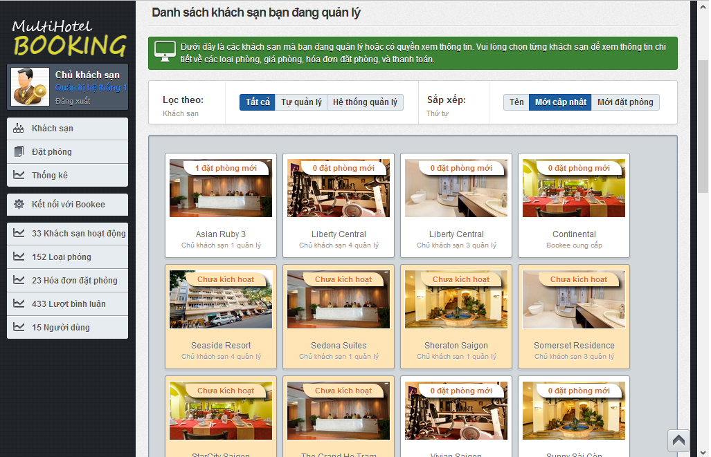

1

Screen . Hotel opening request screen

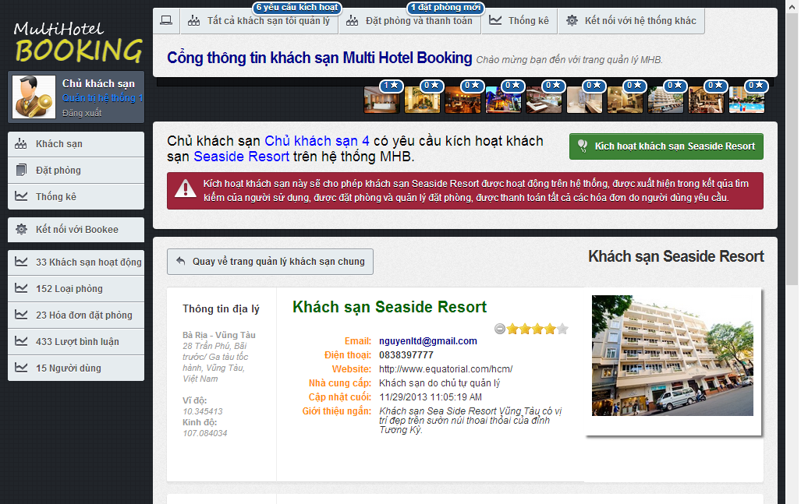

2

Screen . Approve hotel opening request screen

|  |  |
| --- | --- |
| Step | Instruction |
| 1. | Click on a hotel which is not approved by System Admin yet. You will be redirected to the hotel details page. At the top of this page is the content of the request. |
| 2. | Check the hotel information, make necessary contact with the hotel owner to verify the information. If the hotel is valid and can be put into operation on the I-DELIVER system, click the “Kích hoạt Khách sạn X” button, where X is the name of the hotel, to approve this hotel.  After the hotel is approved, you will be redirected back to the dashboard page. |

#### Statistics

This function allows a system admin to manually synchronize information about hotels provided by an external hotel provider (BMT in this case).

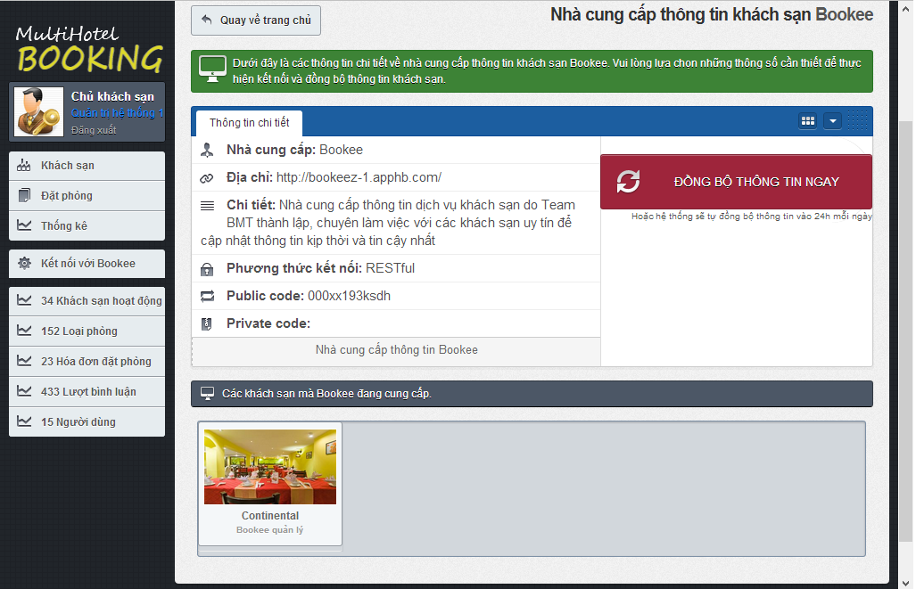

3

2

ĐỒNG BỘ GIÁ

ĐỒNG BỘ THÔNG TIN

1

|  |  |
| --- | --- |
| Step | Instruction |
| 1. | Click the “Kết nối với Bookee” link in the menu bar. You will be redirected to the data synchronization page for this provider. |
| 2., 3. | Click the button “Đồng bộ thông tin” or “Đồng bộ giá” to synchronize data with provider. After you clicked this button, it will takes a while to synchronize the data between the two systems. If you don’t want to wait, you can go to another page, because the synchronization will still continue.  Once the data is completely synchronized, the page will refresh and show a log of the synchronization process. |

#### Add a price

This function allows a hotel owner to add a new price for the selected room type.

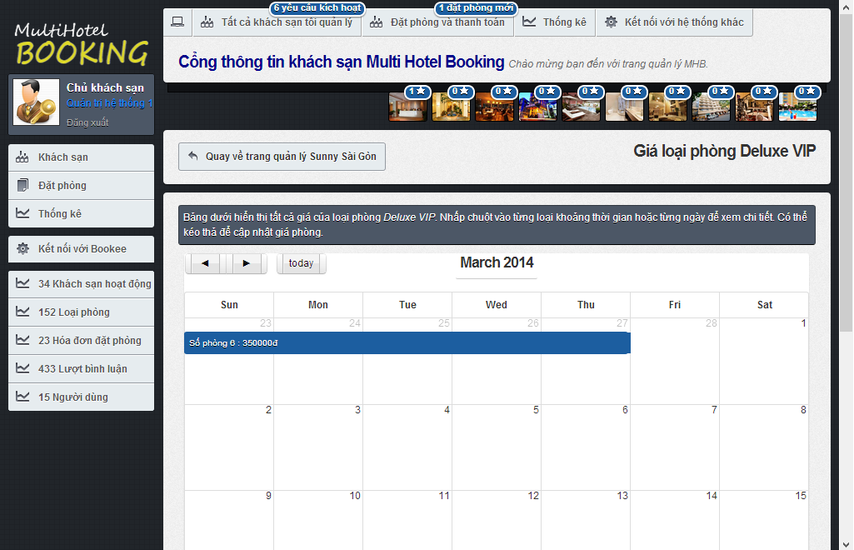

1

Screen . Price calendar screen

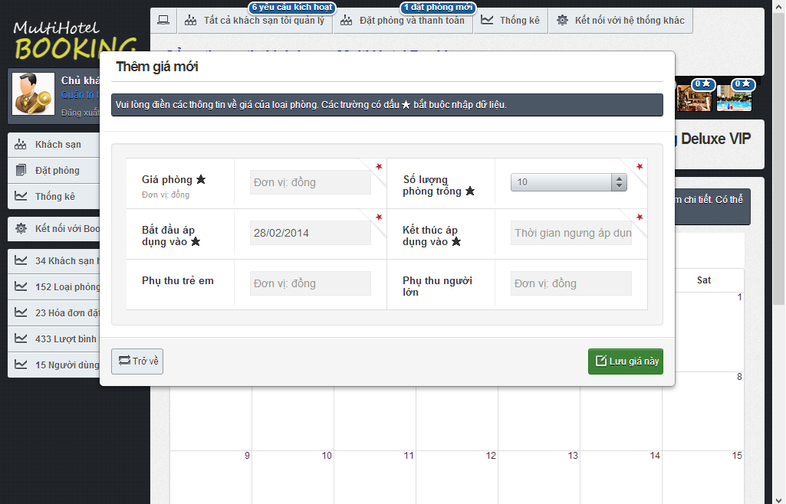

3

2

Screen . Add a price screen

|  |  |
| --- | --- |
| Step | Instruction |
| 1. | Click on an empty date you want to add new price in the price calendar for the selected room. A popup window will be displayed to add a new price for the date. |
| 2. | Provide necessary information about the new price:   * Fill the price in Vietnam Dong in the “Giá phòng” textbox; * Choose the number of rooms available for the period in the “Số lượng phòng trống” dropdown list; * Choose the start date and end date of the price; * Fill the price for extra children in “Phụ thu trẻ em”, if any; * Fill the price for extra adults in “Phụ thu người lớn”, if any.   Your input will be validated as you type. |
| 3. | Click the “Lưu giá này” button. The price will be saved and added to the calendar. |

#### Monitor prices

This function allow a hotel owner to monitor the prices of a room type in a hotel under his or her management. In addition, the screen also allows to see the bookings made on a specific day for a room type.

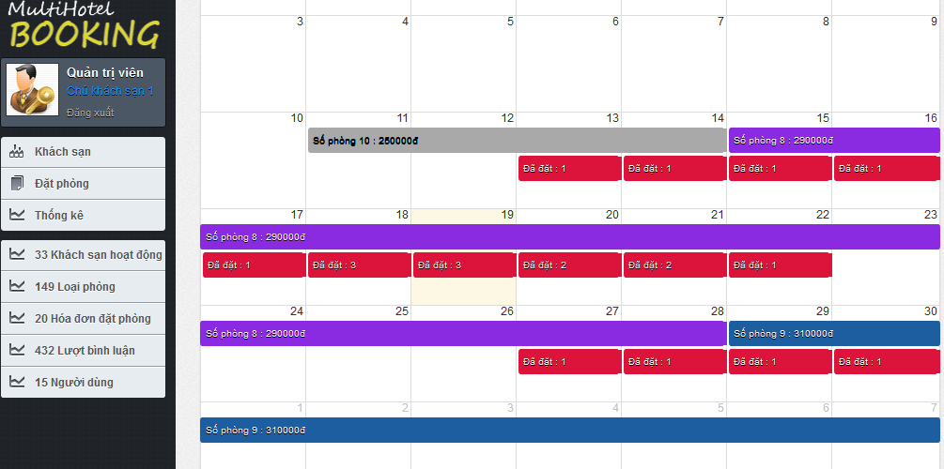

4

3

2

1

Screen . Price calendar screen

|  |  |
| --- | --- |
| Section | Description |
| 1. | A price bar (in gray) that represents a price in the past. You cannot drag, drop, or resize the price bar because the price is no longer active for the room type. |
| 2. | A price bar (in violet) that represents a price crossing from the past to the future (including the current system date). You can drag, drop, and resize the future part of the price bar to update the price in the future. |
| 3. | A price bar (in blue) that represents a price in the future. You can drag, drop, and resize this price bar to update the price in the future. |
| 4. | The number of bookings made on a specific day for the selected room type. |

# Appendix

## Reference

<http://en.wikipedia.org/wiki/Model-view-controller>

<http://www.visual-paradigm.com/product/vpuml/tutorials/>

<http://www.packtpub.com/mastering-ninject-for-dependency-injection/book>

<http://en.wikipedia.org/wiki/Waterfall_model>

<http://www.asp.net/mvc/tutorials/mvc-4>

<http://msdn.microsoft.com/en-us/library/vstudio/ff926074.aspx>

<http://www.csharpfriends.com/articles/getarticle.aspx?articleid=336>

<http://www.uml-diagrams.org/>

<http://en.wikipedia.org/wiki/Database_design>